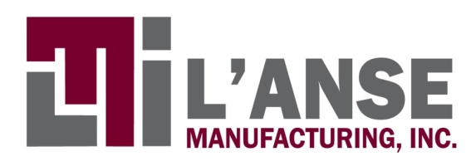

FOR IMMEDIATE RELEASE
DATE: April 20, 2011

L’ANSE MANUFACTURING, INC. Honored as One of the 2011 “Michigan 50 Companies to Watch”

(L’Anse) – L’ANSE MANUFACTURING, INC. has been recognized as one of the 2011 “Michigan 50 Companies to Watch,” an awards program sponsored by the Edward Lowe Foundation and presented by Michigan Celebrates Small Business.

L’ANSE MANUFACTURING, INC. will be honored at an awards ceremony during the seventh annual Michigan Celebrates Small Business event, April 28 in Lansing, Mich.

L’Anse Manufacturing, Inc. (LMI) offers machining services that accelerate products to market. Located in upper Michigan, they have been in business for over 30 years. Their organization is built upon three pillars of service: reliability, agility and capability. LMI takes quality seriously holding both ISO 9001 and AS9100 certifications. They serve multiple industries including medical, military, aviation and performance automotive. LMI offers manufacturing services for all stages of a product life-cycle (prototype, validation, production, and legacy). They can make one part or several thousand depending on the need. LMI works with most metals and plastics. If you can draw it, chances are they can make it.

Mark Massicotte, president of LMI, comments on the award:

I am pleased and humbled to receive this award on behalf of L’Anse Manufacturing. Oftentimes we are so busy that we forget to take a step back and reflect on our accomplishments. The MI 50 Award is a great opportunity to celebrate and recognize our employees, suppliers, customers and community. Their dedication, cooperation and professionalism are critical to our success. As this a state-wide award, I hope others will be inspired to consider our region as a viable manufacturing source.

Companies making it to the “Michigan 50 Companies to Watch” list are a remarkable group of second-stage companies. Defined as having 6 to 99 full-time-equivalent employees and generating $750,000 to $50 million in annual revenue or working capital from investors or grants, these companies form the backbone of Michigan’s economy. Representing all regions of the state and a diverse range of industries, companies like L’ANSE MANUFACTURING, INC. are known for their exceptional entrepreneurial leadership, creation of innovation or use of innovation in creative ways, and their sustainable competitive advantage.

Winners were selected by Michigan-based judges from the banking, economic development, entrepreneurship development and venture capital communities.

Michigan 50 Companies to Watch is presented by Michigan Celebrates Small Business.
PNC Bank is the lead underwriter for Michigan Celebrates Small Business, with additional underwriting support from Clark Hill PLC, Michigan Economic Development Corporation, DTE Energy Foundation, Comcast Business Class, Michigan Certified Development Corporation, Accident Fund Insurance Company of America, and Dynamic Edge.

Michigan Celebrates Small Business is presented in association with the Michigan Small Business & Technology Development Center, Michigan Economic Development Corporation, Small Business Association of Michigan, the U.S. Small Business Administration – Michigan, and the Edward Lowe Foundation.

Information about the 2011 Michigan 50 Companies to Watch program can be found at http://Michigan.CompaniesToWatch.org. For information about Michigan Celebrates Small Business, visit http://MichiganCelebrates.biz.

# # #

